Attachment-1
COORDINATE SYSTEM OF ROCKETS/MISSILES
If three mutually perpendicular Cartesian coordinate axes are assumed to be located at the rocket’s center of mass, the directions of the three axes are determined according to the right-hand rule. These axes are fixed to the rocket and translate and rotate together with it.

1. X-Axis (Longitudinal Axis)
- The x-axis is located at the rocket’s center of mass, with its positive direction extending from the motor exit toward the nose.
- Longitudinal aerodynamic forces are calculated along this axis.
- The rocket’s roll motion occurs about this axis.

2. Y-Axis (Lateral Axis)
- The y-axis is located at the rocket’s center of mass, with its positive direction extending to the right.
- Lateral aerodynamic forces are calculated along this axis.
- The rocket’s pitch motion is defined about this axis.

3. Z-Axis (Vertical Axis)
- The z-axis is located at the rocket’s center of mass, with its positive direction extending downward toward the ground.
- Vertical aerodynamic forces are calculated along this axis.
- The rocket’s yaw motion occurs about this axis..
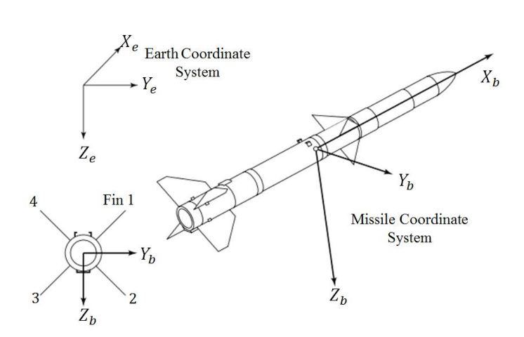
Figure 1 Rocket/Missile & Earth Coordinate System
Since the body-fixed coordinate system on the rocket rotates together with the rocket throughout its motion, vector transformations must be performed from the body coordinate system to the inertial coordinate system in order to express vector quantities such as velocity and acceleration in the inertial frame..
Transformations Between Coordinate Systems

Transformations using DCM Cosine Matrix
The Direction Cosine Matrix (DCM) enables transformations between two coordinate systems using Euler angles (the orientation angles of the body-fixed coordinate system with respect to the inertial coordinate system). The DCM can be calculated as shown below.
$$Y_{b}$$
$$X_{b}$$
$$ψ$$
$$Y_{e}$$
$$X_{e}$$
$R_{z}=\left[\begin{matrix}\cos\left(ψ\right) & \sin\left(ψ\right) & 0 \\ -\sin\left(ψ\right) & \cos\left(ψ\right) & 0 \\ 0 & 0 & 1\end{matrix}\right]$ Rotation matrix about the Z-axis
$$X_{b}$$
$$θ$$
$$X_{e}$$
$R_{y}=\left[\begin{matrix}\cos\left(θ\right) & 0 & -\sin\left(θ\right) \\ 0 & 1 & 0 \\ \sin\left(θ\right) & 0 & \cos\left(θ\right)\end{matrix}\right]$ Rotation matrix about the Y-axis
$$Z_{b}$$
$$Z_{e}$$
$$Z_{b}$$
$$Y_{e}$$
$$Y_{b}$$
$$Z_{e}$$
$$ϕ$$
$R_{x}=\left[\begin{matrix}1 & 0 & 0 \\ 0 & \cos\left(ϕ\right) & \sin\left(ϕ\right) \\ 0 & -\sin\left(ϕ\right) & \cos\left(ϕ\right)\end{matrix}\right]$ Rotation matrix about the X-axis
$$DCM=C_{be}=R_{x}R_{y}R_{z}$$
$$C_{eb}=C_{be}^{T}$$
NOTE: In the figures, $X_{e}, Y_{e}, Z_{e}$ represent the inertial coordinate system, while $X_{b}, Y_{b}, Z_{b}$ represent the body-fixed coordinate system. The DCM transforms any vector from the inertial coordinate system to the body-fixed coordinate system.

Example:
Let a vector V be expressed as $V_{e}$ in the inertial coordinate system and as $X_{b}$ in the body-fixed coordinate system;
$$V_{e}=C_{eb} V_{b}$$
$$V_{b}=C_{be}V_{e}$$
ATTENTION! Since all of the above multiplications are matrix multiplications, the order of multiplication is important.
(In Matlab you can make calculation using the command “$angle2dcm\left(ψ,θ,ϕ,'ZYX'\right)$”)

Transformtions using Quarternionlar
Quaternions are four-element complex number systems used to overcome the singularity (i.e. gimbal lock) issue encountered by the DCM. In DCM calculations, there exists singularity when $θ={90}^{0}$in the multiplication of $R_{x}R_{y}R_{z}$ which means that in DCM calculations the system gives error when $θ={90}^{0}$.
The basic principle of transformation using quaternions is to perform rotation about a single arbitrary axis in space, rather than rotating about three axes as in the DCM.
Assuming that the rotation axis is $\vec{u}$, the rotation angle is α, and the vector to be rotated is $\vec{v}$;
$$q={\left[q_{0}+q_{1}+q_{2}+q_{3}\right]}^{T}$$
$$q={\left[\cos\left(\frac{α}{2}\right),{ u}_{x}\sin\left(\frac{α}{2}\right), u_{y}\sin\left(\frac{α}{2}\right), u_{z}\sin\left(\frac{α}{2}\right)\right]}^{T}$$
$$q^{*}={\left[\cos\left(\frac{α}{2}\right),{-u}_{x}\sin\left(\frac{α}{2}\right), -u_{y}\sin\left(\frac{α}{2}\right), {-u}_{z}\sin\left(\frac{α}{2}\right)\right]}^{T}$$
The key point to note here is that although the rotation angle is α, α/2 is used in the equation in order to prevent the problem encountered in the DCM at $θ={90}^{0}$ (gimbal lock).
$q^{*}$ is the conjugate of $q$’
$$v_{new}=q⊗\vec{v}⊗q^{*}$$
To perform the operation given above, the vector $v$ must be modified, since $q$ and $q^{*}$ contain four elements while $v$ contains three. To resolve this, $P=\left[0,v_{x},v_{y},v_{z}\right]$ is defined, and the operation becomes as follows.
$$v_{new}=q⊗P⊗q^{*}$$
Note:$a⊗b≠b⊗a$
Quaternions contain a scalar and a vector. In the definition given above, the first term represents the scalar, and the remaining three terms define the vector. Thus, quaternions can be written as, $q=\left[s,V_{x},V_{y},V_{z}\right]=\left[s,\vec{V}\right]$ (s: Scalar, $\vec{V}$: vector). According to this $a⊗b$:
$$a⊗b=\left[\begin{matrix}s_{a}s_{b}-\vec{V_{a}}.{\vec{V}}_{b} \\ s_{a}{\vec{V}}_{a}+s_{b}{\vec{V}}_{b}+\left({\vec{V}}_{a}×{\vec{V}}_{b}\right)\end{matrix}\right]$$
$$\left(⊗:Hamilton Multiplication\right)$$
The final value obtained equals to $v_{new}=$ $\left[0,v_{x}^{'},v_{y}'{, v}_{z}'\right]$. The leading zero arises from the nature of quaternions and is discarded at the end. The remaining ${\vec{v}}_{new}=\left[v_{x}^{'},v_{y}'{, v}_{z}'\right]$ is the transformed vector.
Quaternions can be calculated directly from Euler angles. For this purpose, the following formulas are used.
$$c_{ϕ}=\cos\left(\frac{ϕ}{2}\right), s_{ϕ}=\sin\left(\frac{ϕ}{w}\right) \\ c_{θ}=\cos\left(\frac{θ}{2}\right) , s_{θ}=\sin\left(\frac{θ}{2}\right) \\ c_{ψ}=\cos\left(\frac{ψ}{2}\right) , s_{ψ}=\sin\left(\frac{ψ}{2}\right)$$

$$q_{0}=c_{ϕ}c_{θ}c_{ψ}+s_{ϕ}s_{θ}s_{ψ} \left(scalar\right) \\ q_{1}=s_{ϕ}c_{θ}c_{ψ}-c_{ϕ}s_{θ}s_{ψ} \left(vector in \hat{i} direction\right) \\ q_{2}=c_{ϕ}s_{θ}c_{ψ}+s_{ϕ}c_{θ}s_{ψ} \left(vector in \hat{j} direction\right) \\ q_{3}=c_{ϕ}c_{θ}s_{ψ}-s_{ϕ}s_{θ}c_{ψ} \left(vector in \hat{k} direction\right)$$
(In Matlab you can make calculation using the command “ $angle2quat\left(ψ,θ,ϕ,'ZYX'\right)$ ”)
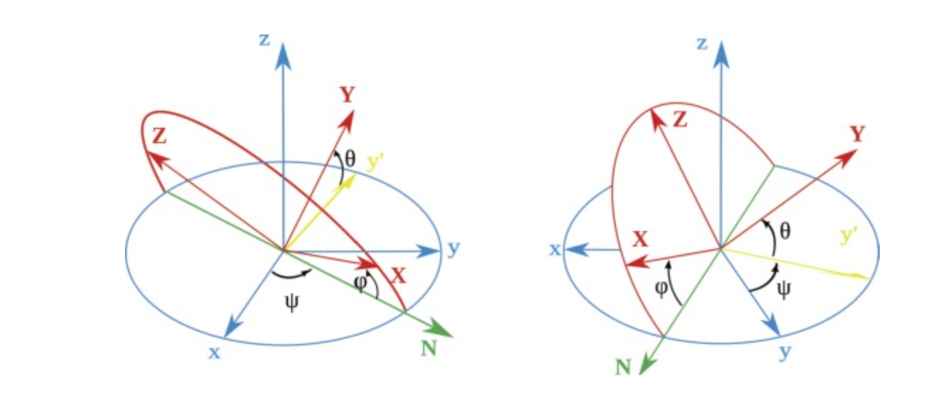
Figure 2 Euler Angles (φ = ϕ)

